

Fergusson College (Autonomous), Pune.

Department of Electronic Science

Report

on

Home Automation

By

# Aditya Sharad Pawale

# Roll no: 236907

MSc II (Sem IV)

Under the guidance of

# Prof. Panchsheela Kamble

(Department of Electronic Science)

# Dr. Kalpana Kulkarni

(Batch In-Charge, Department of Electronic Science)

Fergusson College (Autonomous), Pune – 411004

# Overview

Home automation, also known as "smart home" technology, is the use of technology to automate and control various aspects of a home. It involves connecting devices and systems within a residence to a centralized control system, allowing for remote or automated management of tasks.

• **Connectivity:**

* Home automation relies heavily on network connectivity, often utilizing Wi-Fi, Bluetooth, Zigbee, or Z-Wave protocols.
* This connectivity enables devices to communicate with each other and with central control hubs.

**Control:**

* Users can control home automation systems through various interfaces, including:
  + Mobile apps
  + Voice assistants (like Amazon Alexa, Google Assistant, or Apple Siri)
  + Wall-mounted panels
  + Web interfaces

**Automation:**

* The systems can be programmed to perform tasks automatically based on schedules, sensor input, or user-defined rules.
* This automation enhances convenience, energy efficiency, and security.

**Lighting:**

* Smart lighting systems allow for remote control, scheduling, and dimming of lights.
* They can also be programmed to respond to motion or ambient light levels.

• **Appliance Control:**

* Smart appliances, such as refrigerators, washing machines, and ovens, can be remotely monitored and controlled.

#### **Internet of Things (IOT)**

The term IoT is mainly used for devices that wouldn't usually be generally expected to have an internet connection, and that can communicate with the network independently of human action. For this reason, a PC isn't generally considered an IoT device and neither is a smartphone -- even though the latter is crammed with sensors.

A [smartwatch](https://www.zdnet.com/article/could-your-apple-watch-save-your-life-how-smartwatch-sensors-are-helping-tackle-a-dangerous-heart/) or a [fitness band](https://www.zdnet.com/product/fitbit-ionic/) or other wearable device might be counted as an IoT device

Efficient resource utilization: If we know the functionality and the way that how each device work we definitely increase the efficient resource utilization as well as monitor natural resources.

Minimize human effort: As the devices of IoT interact and communicate with each other and do lot of task for us, then they minimize the human effort.

Save time: As it reduces the human effort then it definitely saves out time. Time is the primary factor which can save through IoT platform.

Enhance Data Collection:

Improve security: Now, if we have a system that all these things are interconnected then we can make the system more secure and efficient.

#### **Components Required**

1. **4 relay module**
2. **4 led bulbs**
3. **Esp8266**

**4 relay module**

A 4-relay module is an electronic device that allows you to control high-voltage or high-current circuits using low-voltage signals from microcontrollers like Arduino, Raspberry Pi, or other similar devices.

Relays act as electrically controlled switches.

They isolate the low-voltage control circuit from the high-voltage/high-current load.

A 4-relay module contains four independent relays, enabling you to control four separate circuits.

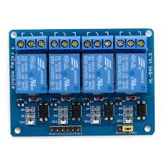

**4 led bulbs**

When considering 4 LED bulbs for demonstration purposes, the focus shifts from basic illumination to showcasing the specific characteristics and advantages of Home Automation Project.

LED bulbs, of 4w, are commonly used for accent lighting, or places where a lower level of light is required. Example, small lamps, or decorative lighting.

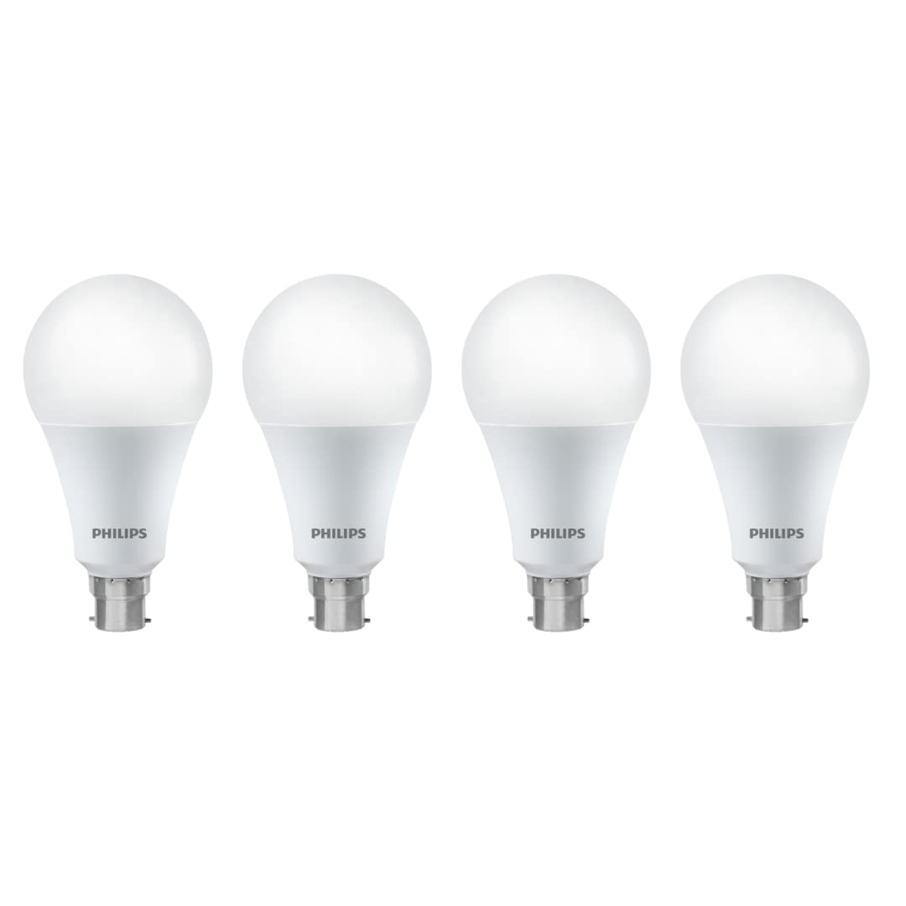  
**Esp8266**

The ESP8266 is a very popular and cost-effective Wi-Fi microcontroller that has played a significant role in the growth of the Internet of Things (IoT).

Its primary function is to provide Wi-Fi capabilities to microcontrollers, allowing devices to connect to networks and the internet.

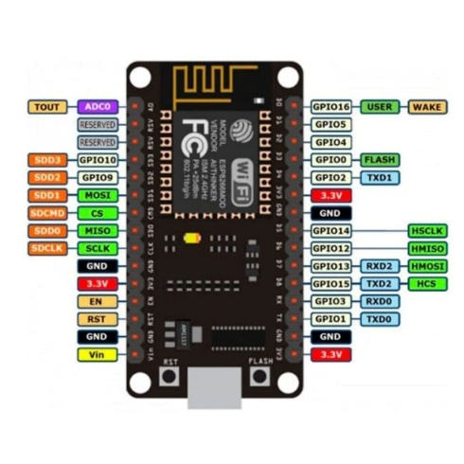

## Testing Componenets

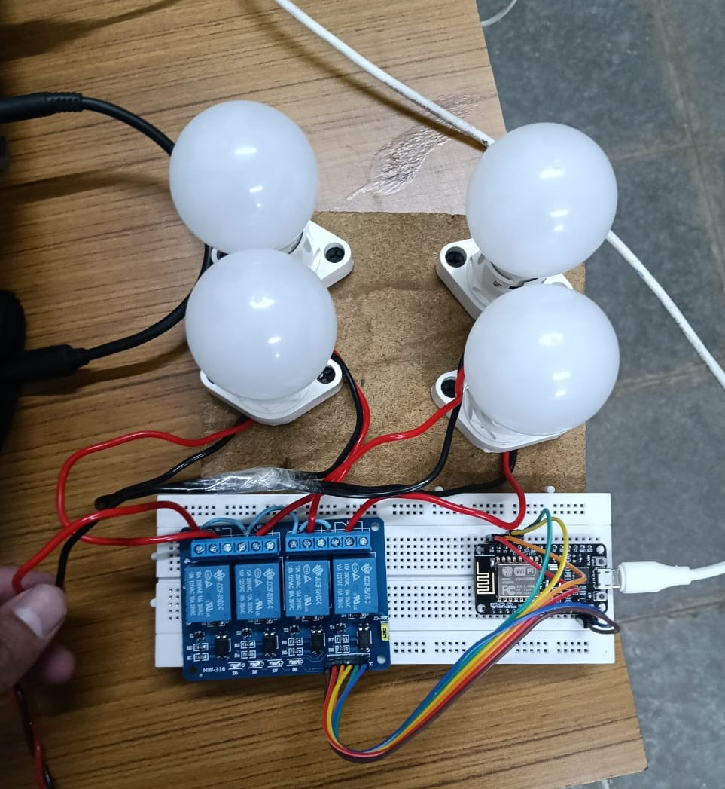

# 

# Code & Output

# 

# <!DOCTYPE html>

# <html>

# <head>

# <meta http-equiv="content-type" content="text/html; charset=utf-8"/>

# <title></title>

# <meta name="generator" content="LibreOffice 7.6.4.1 (Linux)"/>

# <meta name="created" content="00:00:00"/>

# <meta name="changed" content="00:00:00"/>

# <style type="text/css">

# @page { size: 8.27in 11.69in; margin: 0.79in }

# p { line-height: 115%; margin-bottom: 0.1in; background: transparent }

# pre { background: transparent }

# pre.western { font-family: "Liberation Mono", monospace; font-size: 10pt }

# pre.cjk { font-family: "NSimSun", monospace; font-size: 10pt }

# pre.ctl { font-family: "Liberation Mono", monospace; font-size: 10pt }

# </style>

# </head>

# <body lang="en-US" link="#000080" vlink="#800000" dir="ltr"><pre class="western">// wifi controlled home automation using Blynk App &amp; ESP8266

# #define BLYNK_TEMPLATE_ID &quot;YourTemplateId&quot; //blynk template ID

# #define BLYNK_TEMPLATE_NAME &quot;YourTemplateName &quot; //blynk template name

# #define BLYNK_AUTH_TOKEN &quot;4ANo-vG6TpPOvyXdbZgxBBLCVz976NmB&quot; // enter your blynk auth token

# 

# #define BLYNK_PRINT Serial

# #include &lt;gpio.h&gt;

# #include &lt;ESP8266WiFi.h&gt;

# #include &lt;BlynkSimpleEsp8266.h&gt;

# 

# char auth[] = BLYNK_AUTH_TOKEN;

# 

# char ssid[] = &quot;YouWifiName&quot;; // Your Wifi Name

# char pass[] = &quot;YourWifiPasword&quot;; // Your Wifi Password

# 

# //in the below code, we have set all values reverse

# //For value==1, digitalWrite is &quot;LOW&quot; as the realy module is active &quot;LOW&quot; to turn device ON.

# //For value==0, digitalWrite is &quot;HIGH&quot; as Optocoupler based relay is turned OFF when HIGH Input is given

# BLYNK_WRITE(V1)

# {

# int value = param.asInt();

# Serial.println(value);

# if(value == 1)

# {

# digitalWrite(D0, LOW);

# Serial.println(&quot;LED ON&quot;); //Setting Digital PIN as LOW to turn ON Device if relay module is &quot;active low&quot;

# }

# if(value == 0)

# {

# digitalWrite(D0, HIGH);

# Serial.println(&quot;LED OFF&quot;);//Setting Digital PIN as HIGH to turn OFF Device if relay module is &quot;active low&quot;

# }

# }

# 

# BLYNK_WRITE(V2)

# {

# int value = param.asInt();

# Serial.println(value);

# if(value == 1)

# {

# digitalWrite(D1, LOW);

# Serial.println(&quot;LED ON&quot;);

# }

# if(value == 0)

# {

# digitalWrite(D1, HIGH);

# Serial.println(&quot;LED OFF&quot;);

# }

# }

# 

# BLYNK_WRITE(V3)

# {

# int value = param.asInt();

# Serial.println(value);

# if(value == 1)

# {

# digitalWrite(D2, LOW);

# Serial.println(&quot;LED ON&quot;);

# }

# if(value == 0)

# {

# digitalWrite(D2, HIGH);

# Serial.println(&quot;LED OFF&quot;);

# }

# }

# 

# BLYNK_WRITE(V4)

# {

# int value = param.asInt();

# Serial.println(value);

# if(value == 1)

# {

# digitalWrite(D3, LOW);

# Serial.println(&quot;LED ON&quot;);

# }

# if(value == 0)

# {

# digitalWrite(D3, HIGH);

# Serial.println(&quot;LED OFF&quot;);

# }

# }

# 

# 

# void setup()

# {

# Serial.begin(115200);

# Blynk.begin(auth, ssid, pass);

# pinMode(D0,OUTPUT); //GPIO 16 (equivalent to PIN 16 of Arduino)

# pinMode(D1,OUTPUT); //GPIO 05 (equivalent to PIN 05 of Arduino)

# pinMode(D2,OUTPUT);//GPIO 04 (equivalent to PIN 16 of Arduino)

# pinMode(D3,OUTPUT);//GPIO 00 (equivalent to PIN 00 of Arduino)

# }

# 

# void loop()

# {

# Blynk.run();

# }</pre>

# </body>

# </html>